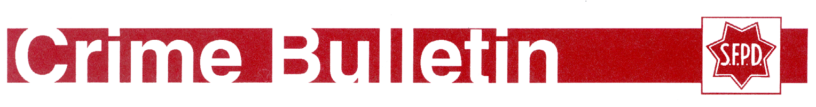
HOMICIDE
$50,000 REWARD
05/06/2020
The San Francisco Police Department has authorized a $50,000 reward for information leading to the identification, arrest and conviction of the suspect(s) responsible for the murders of Lindsay Elaine McCollum and Eddie Wayne Tate.
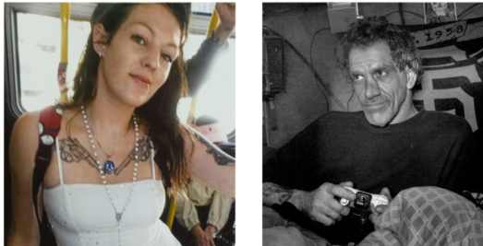
On 12/16/2016 at approximately 8:46PM, a shooting occurred on the northwest corner of 16th Street and South Van Ness Avenue in San Francisco resulting in the murders of Lindsay Elaine McCollum, 27 years old, and Eddie Wayne Tate (AKA: Tennessee), 51 years old. McCollum and Tate were shot while inside a wooden box they used as living quarters on the street.

The San Francisco Police Department is offering a reward to individuals who provide information leading to the arrest and prosecution of the killer(s).
Anyone with information regarding this case may contact Sergeant Mark Hutchings #904 of the San Francisco Police Department Homicide Detail at 1-415-553-7976.

Person(s) with information about this case wishing to remain anonymous may call the SFPD Tip Line at 1-415-575-4444 or by sending a text message to Text-A-Tip (TIP411). Begin the text message with SFPD.

SFPD CASE #161027331

